CANCER 101

A Cancer Education and Training Program for [Target Audience Name]
Version 2 - October 2011
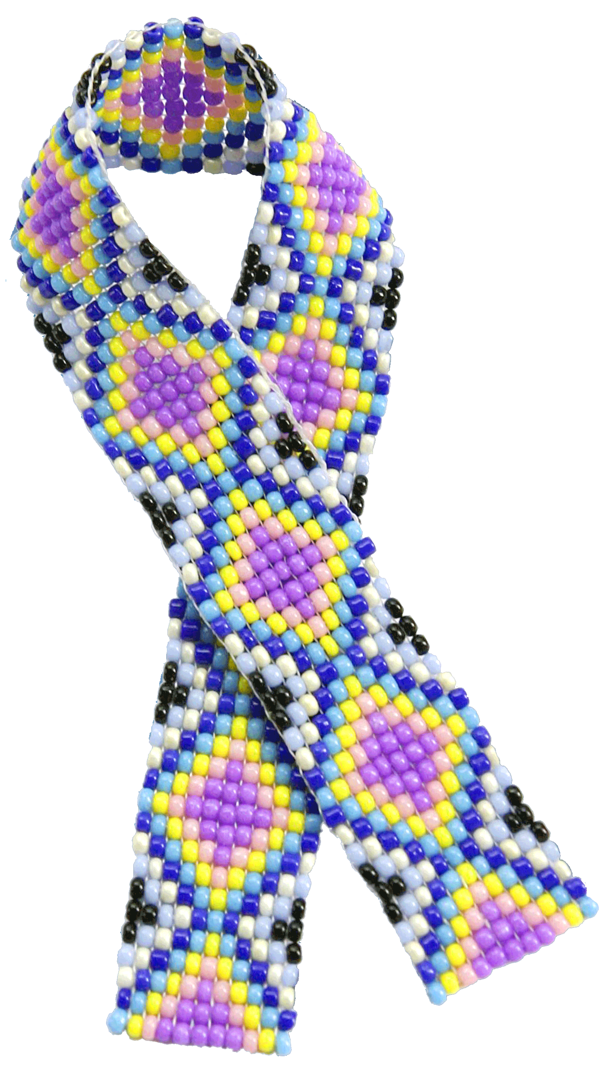

With updates and expanded content written by:
Katherine Josa Briant, MPH, CHES in collaboration with
Teresa Garrett Hill, DNP, MN, RN
In consultation with:
Northwest Portland Area Indian Health Board’s
Northwest Tribal Comprehensive Cancer Project
The original version of Cancer 101, completed in 2002 and updated in 2004, was written by Teresa Garrett Hill, DNP, MN, RN, of the Spirit of EAGLES in consultation with member tribes of the Northwest Portland Area Indian Health Board and the National Cancer Institute’s Cancer Information Service.

CANCER 101

A Cancer Education and Training Program for [Target Audience Name]
Version 2 - October 2011

With updates and expanded content written by:
Katherine Josa Briant, MPH, CHES in collaboration with Teresa Garrett Hill, DNP, MN, RN
In consultation with:
Northwest Portland Area Indian Health Board’s Northwest Tribal Comprehensive Cancer Project

________________________________________________________________________________________________________________________________________________________________________________________________________________________________________________________________________
For further information contact:
Katherine Josa Briant, MPH, CHES  Community Health Educator  Center for Community Health Promotion  Fred Hutchinson Cancer Research Center 1100 Fairview Ave. N., M2-B232  Seattle, WA 98109  Tel: 206-667-1137  Email: kbriant@fhcrc.org | Kerri Lopez (Tolowa Tribe)  Director, NW Tribal Cancer and NW Tribal Diabetes Projects  Northwest Portland Area Indian Health Board  2121 SW Broadway, Suite 300  Portland, OR 97201  Tel: 503-416-3301  Email: klopez@npaihb.org
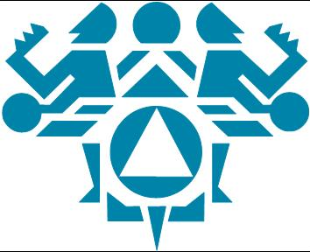
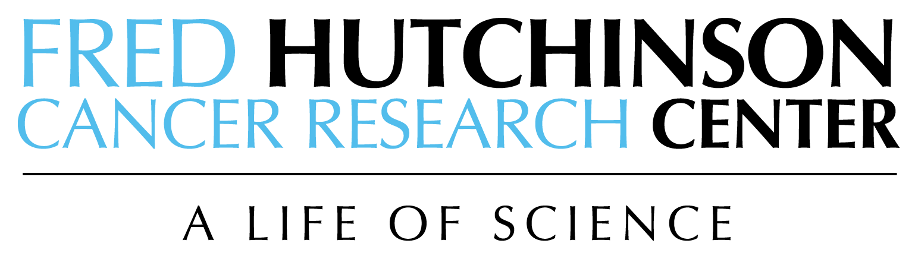

CANCER 101
A Cancer Education and Training Program for [Target Audience Name]

Version 2 - October 2011

The update and expansion of this curriculum was funded by award number 3U01CA114633-06S1 (Hispanic Community Network to Reduce Cancer Disparities) and supported by award number CA153605-01 (Spirit of EAGLES) from the National Cancer Institute (NCI), National Institutes of Health (NIH). It was also supported by Centers for Disease Control and Prevention Cooperative Agreement #5U58DP000786-04 (Northwest Portland Area Indian Health Board’s Northwest Tribal Comprehensive Cancer Project).
Note: The original creation of the curriculum (completed in 2002) was supported by Centers for Disease Control & Prevention Cooperative Agreement #U55/CCU016012 (Northwest Portland Area Indian Health Board’s Northwest Tribal Comprehensive Cancer Project) and NIH grant #U01 CA 86098-01 (Spirit of EAGLES).
The contents of this document are solely the responsibility of the author and do not necessarily represent the official views of the CDC, NCI or the NIH.

You are free to copy, distribute, adapt, and/or transmit this work non-commercially as long as you credit the authors.
Suggested citation: Briant KJ, Garrett Hill T, Northwest Portland Area Indian Health Board’s Northwest Tribal Comprehensive Cancer Project. (2011). Cancer 101: A Cancer Education and Training Program Generic Template. Available at: http://cancer101curriculum.wordpress.com/cancer-101-generic-version/.

Acknowledgements
Many individuals have made this curriculum possible including tribal representatives who attended Cancer 101 trainings and reviewers from research institutions as well as reviewers serving Indian health programs in the Northwest. Together, they have provided invaluable recommendations in the update and expansion of this curriculum.

Contributors also include staff of the National Cancer Institute’s Cancer Information Service and of the Northwest Portland Area Indian Health Board.

Contributing staff from NCI CIS staff members are as follows:
Anabel Cole, PhD  Former Information Specialist  National Cancer Institute’s  Cancer Information Service | Michelle Harrison, MSW  Information Specialist  National Cancer Institute’s  Cancer Information Service
Elizabeth Isaacson, BA  Former Information Specialist  National Cancer Institute’s  Cancer Information Service | Laura Rankin, BA  Resource Specialist  National Cancer Institute’s  Cancer Information Service
Anna Ungar, MA  Former Information Specialist  National Cancer Institute’s  Cancer Information Service | Sandy Valko, MS, CHES  Former Partnership Program Manager  National Cancer Institute’s  Cancer Information Service

Contributing staff for the Northwest Portland Area Indian Health Board:
Luella Azule (Umatilla/Yakima)  Former Project Specialist  Northwest Tribal Cancer Control Project | Janine Dankovchik  Project Specialist  Northwest Tribal Cancer Navigator Project
Peggy Biery (Grand Ronde)  Former Project Specialist  Northwest Tribal Cancer Control Project | Megan Hoopes  Project Director  Northwest Tribal Registry Project
Ruth Jensen (Tlingit)  Former Director  Northwest Tribal Cancer Control Project | Eric Vinson (Cherokee)  Cancer Caregiver/Project Coordinator  Northwest Tribal Cancer Control Project
Barbara Watson (Siletz)
Graphics Designer/Consultant

The Cancer 101 cover photo is provided courtesy of:
Northwest Portland Area Indian Health Board
A special appreciation to:
Beti Thompson, PhD, Principal Investigator of the NCI-funded Center for Community Health Promotion Community Networks Program Center at Fred Hutchinson Cancer Research Center, for believing in the importance of empowering communities through education and supporting this endeavor.
Stella Washines, Chair of the Northwest Tribal Cancer Coalition, NPAIHB board member, and Yakama Tribal Council Woman, for ten years of leadership and commitment to cancer issues in Indian country.

A note of thanks to:
Summer Cox, MPH, Genetics Analyst with the Oregon Genetics Program in the Public Health Division for providing guidance on educational resources on genetics.

Melany Cueva, RN, EdD, of the Alaska Native Tribal Health Consortium for sharing
“Understanding Cancer “
Debra S. Everson, RN, MN, for sharing
“Community Health Representative – Cancer and Advocacy Program Resource Guide”
Marie T. Orines, of Fred Hutchinson Cancer Research Center for explaining how biospecimens are stored and providing a tour of the biorepository at FHCRC.

Member Tribes of the Northwest Portland Area Indian Health Board

Burns Paiute Tribe  Coeur d’Alene Tribe  Confederated Tribes of the Chehalis  Confederated Tribes of the Colville Reservation  Confederated Tribes of the Coos, Lower Umpqua & Siuslaw Indians  Confederated Tribes of the Grand Ronde Confederated Tribes of the Siletz Indians of Oregon  Confederated Tribes of the Umatilla Indian  Reservation  Confederated Tribes of Warm Springs Reservation of Oregon  Coquille Tribe  Cow Creek Band of Umpqua Tribe of Indians  Cowlitz Indian Tribe  Hoh Tribe  Jamestown S’Klallam Tribe  Kalispel Tribe of Indians  Klamath Tribes  Kootenai Tribe  Lower Elwha Klallam Tribe  Lummi Nation | Makah Indian Nation  Muckleshoot Indian Tribe  Nez Perce Tribe  Nisqually Tribe  Nooksack Tribe  Northwest Band of Shoshone Indians  Port Gamble S’Klallam Tribe  Puyallup Tribe of Indians  Quileute Tribe  Quinault Nation  Samish Indian Tribe  Sauk-Suiattle Indian Tribe  Shoalwater Bay Indian Tribe  Shoshone-Bannock Tribes  Skokomish Tribal Nation  Snoqualmie Indian Tribe  Spokane Tribe of Indians  Squaxin Island Tribe  Stillaguamish Tribe  Suquamish Tribe  Swinomish Indian Tribal Community  Tulalip Tribes  Upper Skagit Tribe  Yakama Nation

Reviewers
Collaborators extend their gratitude to the distinguished panel of reviewers whose experience and expertise have contributed to the value of these modules.
Linda Sue Aitken  Community Health Representative  Kootenai Tribe | Lael Alexander  Billing Clerk  Kootenai Tribe
Cheryl Arenella, MD, MPH*  Cancer Education Program Specialist,  Office of Communication and Education  National Cancer Institute | Judith Charley, CHES*  Community Health Education Specialist  Confederated Tribes of Warms Springs
Freida Eng, MD  Nisqually Tribal Clinic | Barbara Hoffman, RN  Tribal Community Health Nurse  Suquamish Indian Tribe
Kerri Lopez*  Director, Northwest Tribal Cancer Project  Northwest Portland Area Indian Health Board | Shari S. Marrazzo, RN, OCN, CAN  Warm Springs Service Unit  Indian Health Service
Catherine Mizzen, ARNP  Swinomish Indian Health Clinic | Karen Morgan, RN  Community Health Nurse,  Wadaitka Health Center  Burns Paiute Tribe
Elizabeth Peterson, RN, BSN  Community Health Nurse  Nooksack Tribal Clinic | Janet Stafford, RN  Public Health Nurse  Quinalt Indian Nation
Twila Teeman*  Health Director  Burns Paiute Tribe | Noreen Thompson, RN  Cow Creek Health and Wellness  Cow Creek Band of Umpqua Indians
Mark Thornquist, PhD*  Director, Comprehensive Center for the Advancement of Scientific Strategies  Fred Hutchinson Cancer Research Center | Stephanie Trahant*  Patient Navigator  Shoshone Bannock Tribal Health
Robin Troxell  Health Administrator  Northwest Band of Shoshone Indians | Shirley Wagoner*  Advanced Registered Nurse Practitioner  Kalispel Tribe
Paul Willard, MD  Clinical Director, David C. Wynecoop Memorial Clinic, Wellpinit Service Unit  Indian Health Service | Bev Wright, ARNP  Women’s Health Specialist, Breast and Cervical Health Program  South Puget Intertribal Planning Agency
* denotes reviewers for the three new modules added to the curriculum
Preface
The Cancer 101 curriculum has come a long way! It began in the late 90’s as a collaboration between tribes and organizations dedicated to addressing health disparities among Native people. The vision was the creation of a tool that would be culturally relevant, increase knowledge and understanding about cancer, and empower tribal communities in the Pacific Northwest to address cancer issues. In 2002, the vision became a reality, and since then, Cancer 101 has been used across the country with Native populations as well as other ethnic and cultural groups.
Over time, we’ve learned from personal experience, as well as from other users, that the curriculum was easy to use and that it was an effective tool to increase knowledge and awareness about cancer. In an effort to document evidence about Cancer 101’s effectiveness, we continued to work with the Northwest Tribal Cancer Coalition to evaluate the curriculum as a community-based intervention, which was completed in 2009. The results established Cancer 101 as an evidence-based curriculum for AI/AN that has been research tested and found to be effective. Cancer 101 is found to increase knowledge about cancer and cancer control, change attitudes towards cancer risk and risk reduction, change the way people think about cancer issues and concerns in the communities, and empower training participants to access resources to act on cancer control issues in their communities.
In working with tribal community members to evaluate the curriculum, and the Northwest Tribal Cancer Coalition Chair, we learned that there a need to address additional topics. Those additional topics were briefly touched upon but not included in Version 1 of the Cancer 101 curriculum. Cancer 101 (Version 2) adds this additional content.

Cancer 101, Version 2 includes the seven modules from Version 1. Version 1 content was updated to reflect the most current information available on cancer data, screening guidelines, and risk factors. Cancer 101, Version 2 features three new modules: Role of Genes in Cancer, Biospecimens and Biobanking, and Chronic Conditions and Cancer. To improve the flow of the curriculum content, these three new modules have been placed in between the original modules in the original version of Cancer 101.

The process to update and expand the curriculum included interviews, presentations and volunteer readers. Past Cancer 101 trainees were interviewed to learn how the curriculum could be improved. We presented the three new module topics at a Northwest Tribal Cancer Coalition meeting in May 2011 and five reviewers volunteered to read the content and provide feedback and suggested edits. The Confederated Tribes of Warm Springs offered to host a pilot session for the three new modules. We are grateful to all the individuals who took the time to talk with us, review materials, and participate in training. Their input has been invaluable in this process.

We are dedicated to continuing to work together with tribes in their efforts to reduce the burden of cancer. We hope that Cancer 101, Version 2 will be a useful tool in your community. We look forward to hearing from you as you use it. Your feedback will help us continue to refine and improve the curriculum.

Kerri Lopez Kathy Briant Teresa Garrett Hill
Table of Contents

Each learning module is designed for presentation as a 30- to 40- minute education session; or the entire curriculum may be presented as a two-day workshop on cancer education. Learning modules include stated goals and objectives for each topic, pre and post self-assessment, PowerPoint presentation, glossary, references, and resource materials as appropriate.

Learning Module 1
“Cancer among [Target Population]”
…provides information about the growing health concern of cancer among [target population] including contributing factors, interpretation of current data, and survival statistics.
Module 1: Cancer Among [Target Population] M1-1
Pre/Post Self-Assessment M1-2
Pre/Post Self-Assessment Answer Key M1-3
Section 1: Cancer Background M1-4
Section 2: What is Known and not Known About Cancer among
[Target Population} M1-6
Section 3: Cancer Survival among [Target Population] M1-8
Glossary of Terms M1-10
Resources for Learning More M1-11
References M1-12

Learning Module 2
“What Is Cancer?”
…describes how cancer develops and discusses the five main groups of cancer.
Module 2: What is Cancer? M2-1
Pre/Post Self-Assessment M2-2
Pre/Post Self-Assessment Answer Key M2-3
Section 1: What is Cancer? M2-4
Section 2: Benign Versus Malignant Tumors M2-6
Section 3: Types of Cancer M2-7
Glossary of Terms M2-8
Resources for Learning More M2-10
References M2-11

Learning Module 3
“Cancer Risk Factors and Risk Reduction”
…focuses on understanding cancer risk factors and learning how to reduce risks associated with cancer.
Module 3: Cancer Risk Factors and Risk Reduction M3-1
Pre/Post Self-Assessment M3-2
Pre/Post Self-Assessment Answer Key M3-3
Section 1: What is a Risk Factor? M3-4
Section 2: Risk Reduction M3-6
Glossary of Terms M3-9
Resources for Learning More M3-11
References M3-13

Learning Module 4
“Role of Genes in Cancer”
…describes genes, their role in the body, how changes in their function may lead to cancer, and discusses genetic testing.
Module 4: Role of Genes in Cancer M4-1
Pre/Post Self-Assessment M4-2
Pre/Post Self-Assessment Answer Key M4-3
Section 1: What Are Genes? M4-4
Section 2: Gene Mutations M4-8
Section 3: Genetic Testing M4-10
Glossary of Terms M4-15
Resources for Learning More M4-20
References M4-23

Learning Module 5
“Cancer Screening and Early Detection”
…discusses the components of early detection and barriers associated with practicing early detection, and describes common symptoms associated with cancer.
Module 5: Cancer Screening and Early Detection M5-1
Pre/Post Self-Assessment M5-2
Pre/Post Self-Assessment Answer Key M5-3
Section 1: Cancer Screening & Early Detection M5-4
Section 2: Barriers to Cancer Screening & Early Detection M5-12
Section 3: Possible Symptoms of Cancer M5-14
Cancer Sites Reference Worksheet M5-16
Glossary of Terms M5-21
Resources for Learning More M5-24
References M5-26

Learning Module 6
“Cancer Diagnosis and Staging”
…discusses how cancer is diagnosed and how cancer stage is determined.
Module 6: Cancer Diagnosis and Staging M6-1
Pre/Post Self-Assessment M6-2
Pre/Post Self-Assessment Answer Key M6-3
Section 1: Cancer Diagnosis and Staging M6-4
Section 2: Staging of Cancer M6-7
Glossary of Terms M6-9
Resources for Learning More M6-11
References M6-12

Learning Module 7
“Basics of Cancer Treatment”
…discusses a variety of methods used in the treatment of cancer and their potential side effects.
Module 7: Basics of Cancer Treatment M7-1
Pre/Post Self-Assessment M7-2
Pre/Post Self-Assessment Answer Key M7-3
Section 1: How We Become Well Again M7-4
Section 2: Treatment Methods M7-6
Section 3: Managing Physical Effects M7-11
Glossary of Terms M7-12
Resources for Learning More M7-15
References M7-18

Learning Module 8
“Biospecimens and Biobanking”
…provides an understanding of what biospecimens are, how they are collected, stored and used, as well as the importance of biospecimens to cancer research.
Module 8: Biospecimens and Biobanking M8-1
Pre/Post Self-Assessment M8-2
Pre/Post Self-Assessment Answer Key M8-3
Section 1: What Are Biospecimens? M8-4
Section 2: Why Are Biospecimens Important? M8-8
Section 3: How Are Participants Protected? M8-11
Glossary of Terms M8-16
Resources for Learning More M8-19
References M8-21

Learning Module 9
“Chronic Conditions and Cancer”
…defines chronic disease and describes common types, their risk factors, signs and symptoms, contributing factors, and the growing concern about the increase in numbers of persons affected.
Module 9: Chronic Conditions and Cancer M9-1
Pre/Post Self-Assessment M9-2
Pre/Post Self-Assessment Answer Key M9-3
Section 1: What is a Chronic Disease? M9-4
Section 2: Common Chronic Conditions M9-6
Section 3: Concerns About Chronic Conditions M9-13
Section 4: Preventing Chronic Conditions M9-18
Glossary of Terms M9-20
Resources for Learning More M9-24
References M9-25

Learning Module 10
“Support for Patients and Caregivers”
…addresses some of the psychological and social issues that affect cancer patients and their caregivers and discusses ways to be supportive.
Module 10: Support for Patients and Caregivers M10-1
Pre/Post Self-Assessment M10-2
Pre/Post Self-Assessment Answer Key M10-3
Section 1: Coping with the Cancer Diagnosis—How to be Supportive M10-4
Section 2: Life after Cancer Treatment—On the Path to Recovery M10-7
Section 3: Life after Cancer Treatment—Survivorship M10-8
Glossary of Terms M10-10
Resources for Learning More M10-11
References M10-14

Trainer Section
…consists of the Cancer 101 adaptation guidelines and training tips.
Cancer 101 Adaptation Guidelines T-1
Training Tips T-10
Trainer Activity Report T-13
Evaluation
…consists of two documents: Healthy Changes Checklist, which can be distributed to participants, and a template for an overall training/workshop evaluation.
Healthy Changes Checklist - Next Steps After Training! E-1
Workshop Evaluation E-3

Resources
…contains a list of national organizations involved in cancer control. You may choose to add resources from your community. There is also a list of resource materials that you may want to provide at a training, with ordering information.
Organizational Resources R-1
Brochures and Pamphlets R-5

